In & Not in Operators in SQL

Operators which can test a list of values

IN, NOT IN , BETWEEN , NOT BETWEEN

Understanding ALL, ANY/SOME, Exists in SQL

All , ANY/SOME keywords are used with the where/having clause. All , Any/Some operates on subqueries that return multiple values.

All returns true if all of the subquery values meet the condition , ANY/SOME returns true if ANY/SOME of the subquery values meet the condition .

**Union & Union All operators in SQL :**

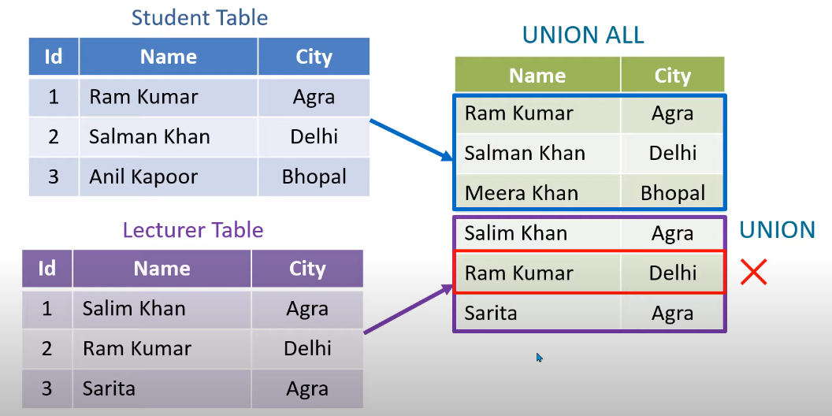

Syntax of Union & Union All :

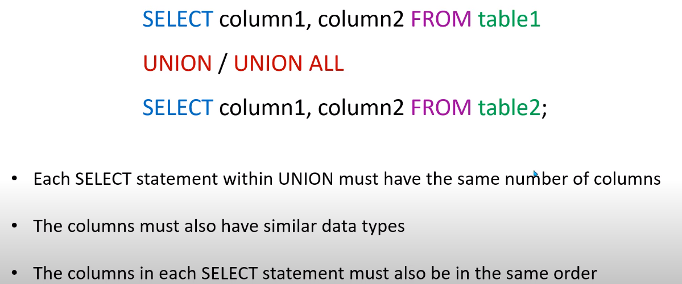

**Aggregate Functions Or SQL inbuilt Functions:**

These functions return a single value after performing calculations on a group of values

Eg – avg(), count(), max(), min() , sum(), Lcase(), Ucase() , Round() , first(), last(), Mid(name,start,end)

**SQL Alias - AS Keyword :**

Alias is used to give an alias name to a table or a column, which can be a resultset table too. This is quite useful in case of large or complex queries. Alias is mainly used for giving a short alias name for a column or a table with complex names.

Syntax of Alias for table names,

SELECT column-name FROM table-name AS alias-name

Eg : SELECT * FROM Employee_detail AS ed;

SELECT customer_id AS cid FROM Emp;

**SQL CLAUSES**

SQL clause helps us to retrieve a set or bundles of records from the table.

SQL clause helps us to specify a condition on the columns or the records of a table.

Different clauses available in the Structured Query Language are as follows:

1. WHERE CLAUSE
2. GROUP BY CLAUSE
3. HAVING CLAUSE
4. ORDER BY CLAUSE

Group By Clause

* + Group by clause is utilized with the select statement.
  + In SQL, Group by clause is one the tool to summarize or aggregate the data series.
  + The group by statement in SQL is used to arrange identical data into groups.
  + Group by typically also involves aggregate: Count, Max , Sum , Avg etc

Syntax :

Select Column_name

From table_name

Where Condition

Group by Column_name

Order by column_name;

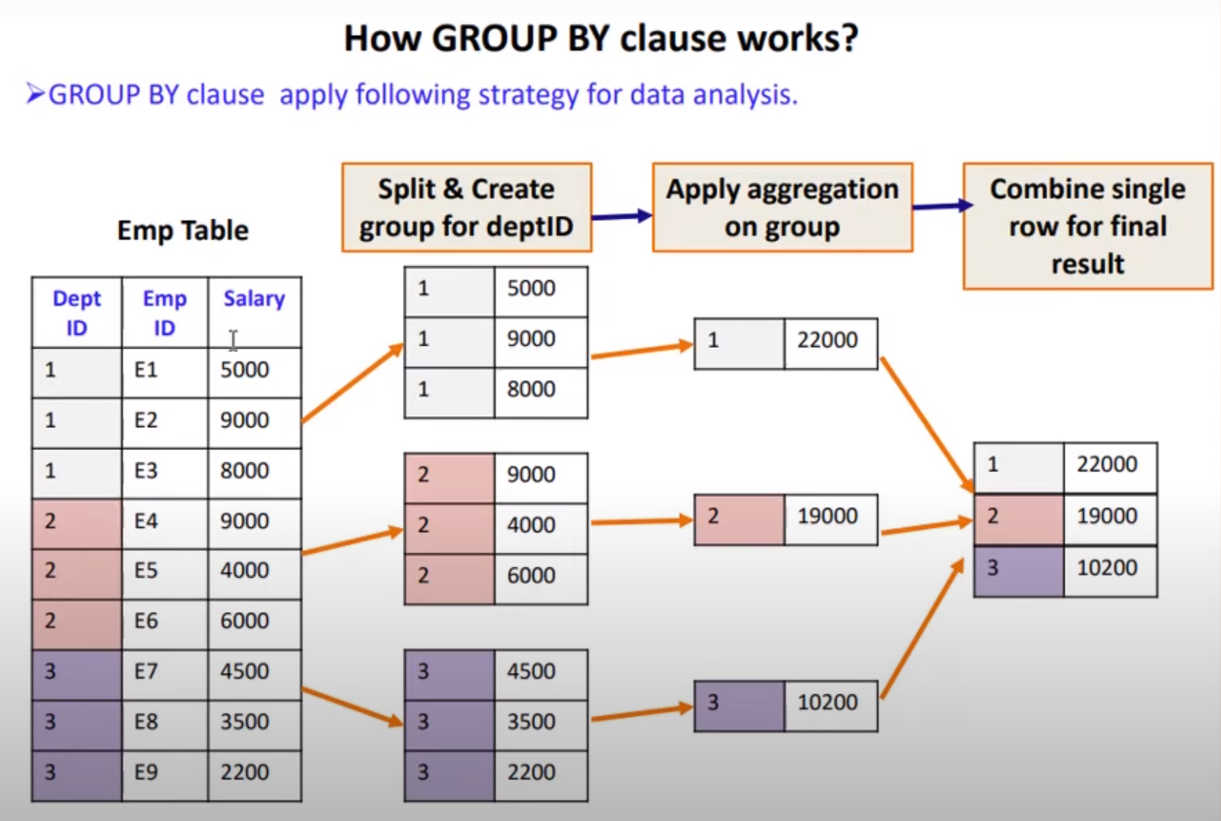

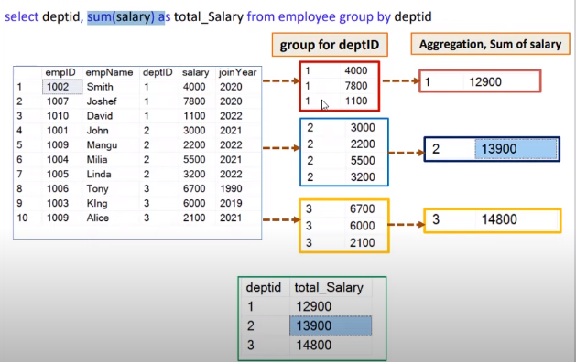

|  |  |  |  |
| --- | --- | --- | --- |
| **s.no** | **WHERE clause** | **s.no** | **HAVING clause** |
| 1 | used to filter the records from the table based on the specified condition | 1 | used to filter records from the groups based on the specified condition |
| 2 | Implemented in row operation | 2 | implemented in column operation |
| 3 | Can be used without GROUP BY clause | 3 | Can’t be used without Group by clause |
| 4 | Can be used with SELECT, UPDATE, DELETE statement | 4 | Can only be used with SELECT statement |
| 5 | Doesn’t contain aggregate function | 5 | Contains aggregate functions |
| 6 | Filters rows before grouping performed | 6 | Filters rows after grouping is performed |
| 7 | Group by clause is used after Where C. | 6 | Group by clause is used before Having C. |